**Medium programs**

1. Ganesh Reddy

192110023

11

#include<iostream>

using namespace std;

int main()

{

int r;

const float pi=3.14;

cout <<"enter the value of r=";

cin >>r;

cout <<"area of circle=";

float area=pi*r*r;

cout << area;

}

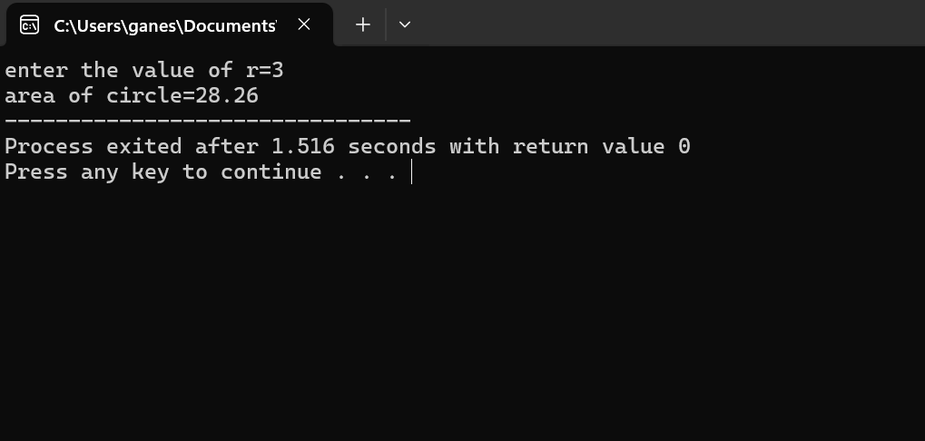

12

#include <iostream>

int main() {

int integerNum;

float floatNum;

std::cout << "Enter an integer number: ";

std::cin >> integerNum;

std::cout << "Enter a float number: ";

std::cin >> floatNum;

if (integerNum != 0) {

float result = floatNum / integerNum;

std::cout << "Result of floatNum / integerNum: " << result << std::endl;

} else {

std::cout << "Error: Division by zero!" << std::endl;

}

}

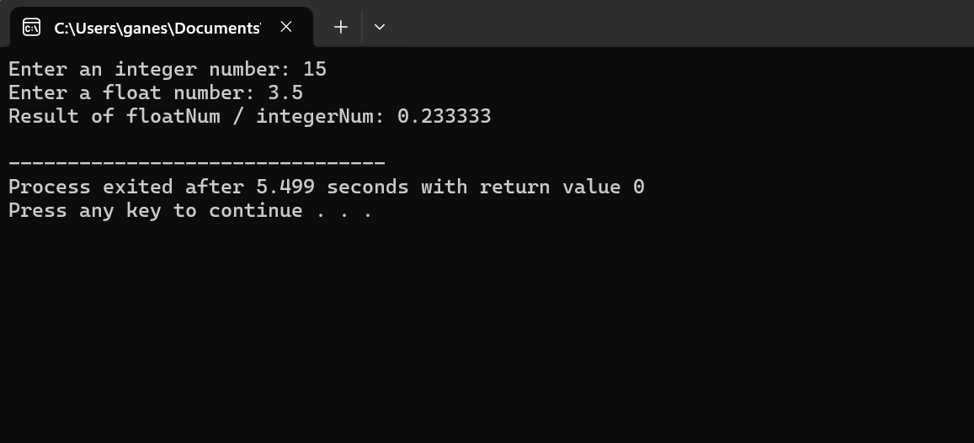

13

#include <iostream>

int main() {

int year;

std::cout << "Enter a year: ";

std::cin >> year;

if ((year % 4 == 0 && year % 100 != 0) || (year % 400 == 0)) {

std::cout << year << " is a leap year." << std::endl;

} else {

std::cout << year << " is not a leap year." << std::endl;

}

return 0;

}

14

#include<iostream>

using namespace std;

int main()

{

float a,b;

cout <<"enter the length and width";

cin >>a >>b;

float area=a*b;

cout <<"area of rectangle="<<area;

}

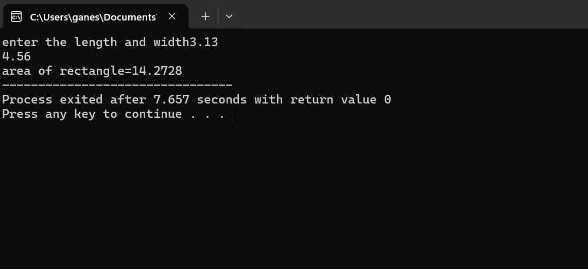

15

#include<iostream>

using namespace std;

int main()

{

int n;

cout << "enter the integer=";

cin >> n;

if ((n&1)==0)

{

cout <<"even number";

}

else

{

cout <<"odd number";

}

}

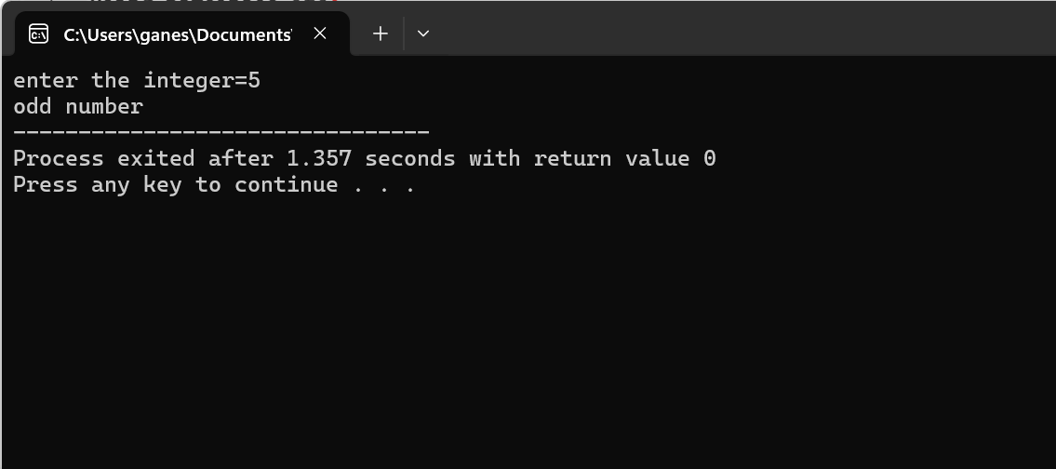

16

#include<iostream>

using namespace std;

int main()

{

int n;

cout <<"enter your choice (0-12)=";

cin >>n;

switch(n)

{

case 1:

cout <<"Janurary";

break;

case 2:

cout <<"February";

break;

case 3:

cout <<"March";

break;

case 4:

cout <<"April";

break;

case 5:

cout <<"May";

break;

case 6:

cout <<"June";

break;

case 7:

cout <<"July";

break;

case 8:

cout <<"August";

break;

case 9:

cout <<"September";

break;

case 10:

cout <<"October";

break;

case 11:

cout <<"November";

break;

case 12:

cout <<"December";

break;

}

}

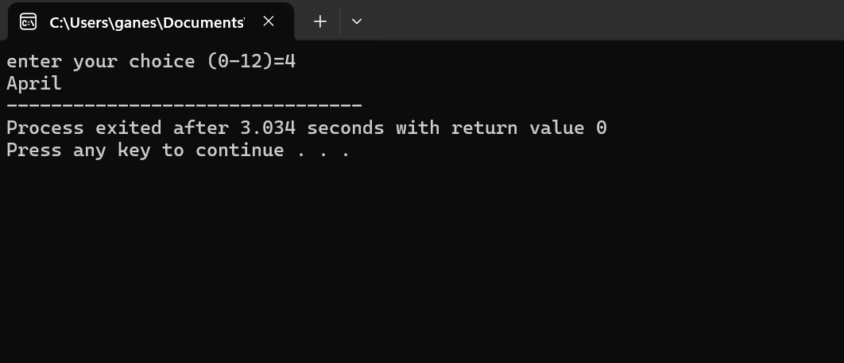

17

#include<iostream>

using namespace std;

int main()

{

float r;

const float pi=3.14;

cout <<"enter the radius=";

cin >>r;

float v=4/3*pi*r*r*r;

cout <<"volume of sphere="<<v;

}

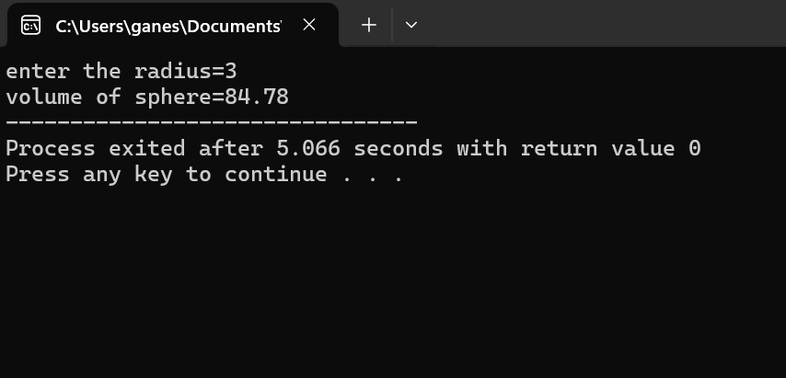

18

#include<iostream>

using namespace std;

int main()

{

int a,b;

cout <<"enter two integers=";

cin >>a>>b;

if(b!=0)

{

int d=a/b;

cout <<d;

}

else

{

cout <<"we cant divide with zero";

}

}

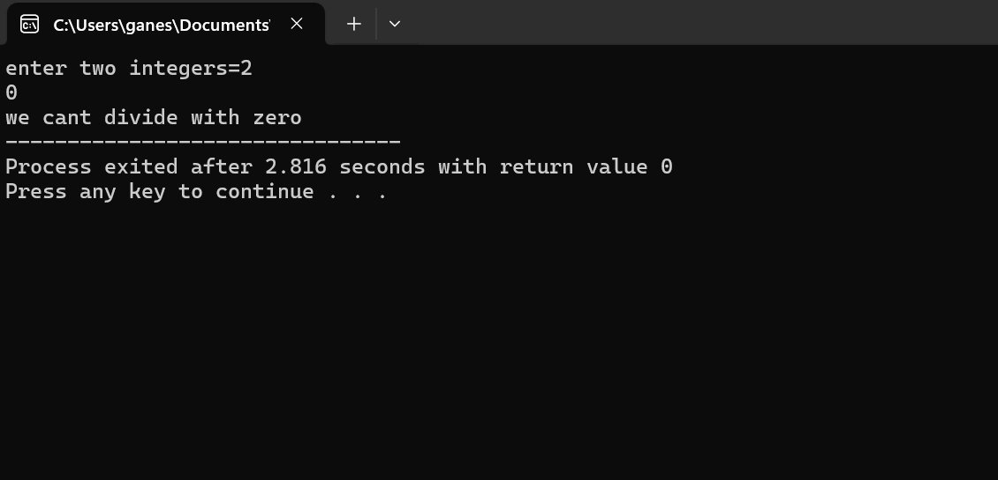

19

#include <iostream>

class Complex {

private:

double real;

double imag;

public:

Complex () : real(0), imag(0) {}

Complex (double r, double i) : real(r), imag(i) {}

double getReal() const { return real; }

double getImag() const { return imag; }

Complex operator+(const Complex& other) const {

return Complex(real + other.real, imag + other.imag);

}

Complex operator-(const Complex& other) const {

return Complex(real - other.real, imag - other.imag);

}

};

std::ostream& operator<<(std::ostream& out, const Complex& c) {

out << c.getReal() << " + " << c.getImag() << "i";

return out;

}

int main() {

Complex c1(2.5, 3.7);

Complex c2(1.4, -0.8);

Complex sum = c1 + c2;

std::cout << "Sum: " << sum << std::endl;

Complex diff = c1 - c2;

std::cout << "Difference: " << diff << std::endl;

return 0;

}

20

#include<iostream>

using namespace std;

int main()

{

int n,i,fact=1;

cout <<"enter the number=";

cin >>n;

for(i=1;i<=n;i++)

{

fact=fact*i;

}

cout <<"factorial of "<<n<<"="<<fact;

}

